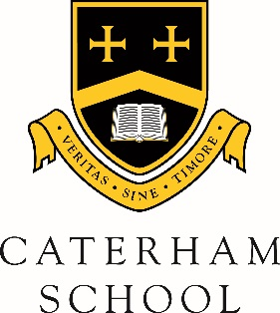

Music Department

Application for ABRSM Music Theory Lessons

There is a once weekly Theory Club run by Mr. Hill, Head of Instrumental Music every Thursday from 1:10-1:50pm in the Fairmaner Room. There is no charge for attendance at this club.

In addition we can offer both Individual and group lessons of 2 or 3 students of similar ability outside of lesson time. Group lessons are dependent upon availability. Lessons can be of 20 minute or 40 minute duration and there would be an average of 10 lessons per term. There is a charge for these lessons (details below) and payment should be made to the Visiting MusicTeacher direct. ABRSM Music Theory exams take place in school on a termly basis.

Please complete:
Surname of Pupil
First Name/Known as
Address

Telephone number
Email address
Age & Date of Birth
Year Group

Type of Lesson | Duration | Cost Per Lesson | Please tick
Theory Club | 40 minutes | NO CHARGE
Individual lesson | 20 minute | £13.80
Individual lesson | 40 minute | £27.60
Group Lesson 2 students | 20 minute | £6.90
Group Lesson 3 students | 20 minute | £4.60
Group lesson 2 students | 40 minute | £13.80
Group Lesson 3 students | 40 minute | £9.20

Latest Music Theory exam grade (if applicable): ________________________________________

Signed Parent/Guardian ____________________________________ Date _________________

Please return this form to the Music Office.

For further information please contact music.enquiries@caterhamschool.co.uk

