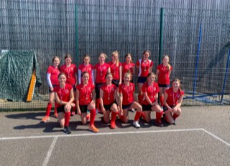

Caterham Medal Success for Oxted HC at League Finals

Over the weekend, 5 Caterham students represented Oxted U14s at the league finals in Folkestone. A tough opening game vs Folkestone led to a very narrow 2-1 defeat, but the girls came roaring back with wins against Canterbury and Guildford. The girls finished second overall and took home the silver medal. It was a great reward for a terrific season, and it is fantastic to see so many of our hockey players representing Oxted HC.
Congratulations go to 3rd years Ava W. and Coral M., and to 2nd years Jess L., Ava P. and Elise T.

