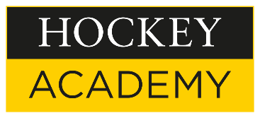

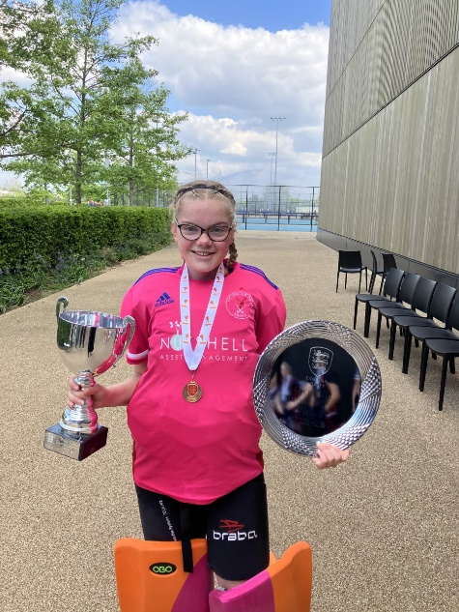
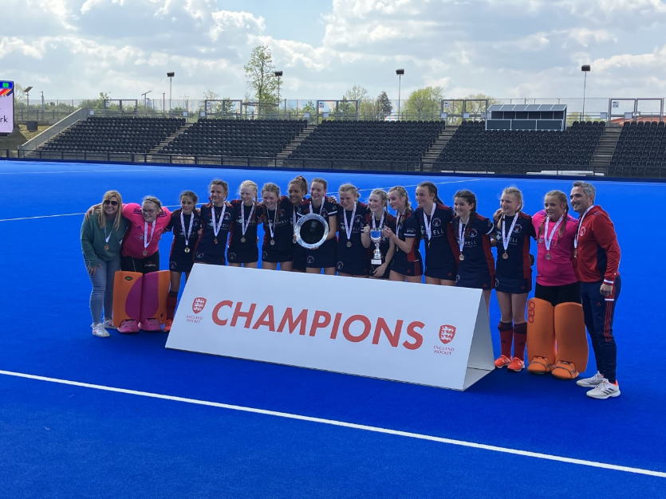

National Title Win for Lilian dB.
Over the weekend, 2nd year goalkeeper Lilian dB. represented her club, Knole Park, at the Lee Valley Olympic Park in the England Hockey Supra League finals.
The Supra League is a new junior competition, bringing together the winners of the four Tier 1 Divisions that have run since January. At Lee Valley, the Girls U14 competed in semi-finals followed by finals and 3/4 play-offs.

The teams qualified for the Divisions from the eight Areas Tier 1 competitions pre-Christmas and the Divisions were broadly based on dividing the country into 4 geographic groups bringing together the best teams from the country in each age group.

Knole Park overcame Bowdon HC 4-0 in the semi-finals before going on to win their final against Surbiton HC 3-1. This is a fantastic achievement for Lilian who caps off a stellar year for Knole Park HC, having already won the National Cup title. Well done Lilian!

