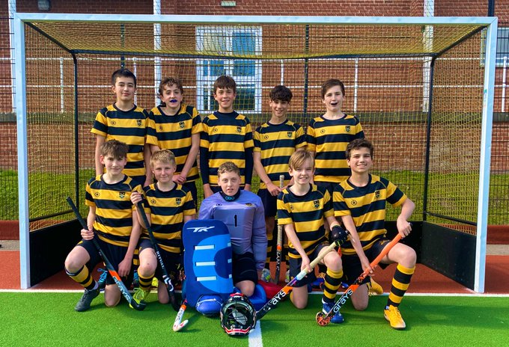

U13B Surrey Hockey Plate Champions
On Thursday 17 March, it was the turn of the U13Bs to represent the school in tournament action, this time hosting the U13 Surrey Hockey Plate. The sun shone and the sky was blue for what was a thoroughly enjoyable day on the astro as the boys played their hearts out, winning all three group games (scoring 11 and conceding 1) against St George’s College, Reigate Grammar and Barrow Hill before progressing to the final against St George’s.
Having beaten them in the group stages, the boys went in to the final full of confidence, but the game was much tighter this time, with the boys failing to convert a number of chances and Noah P. in goal producing some excellent saves. As the game ebbed and flowed, the boys established a foothold, and quick fire goals before half time and just before the end of the game saw the boys take the game and the title.
It was impressive to see the strength in depth of this year group, following the success of the U13As earlier in the week and we really look forward to seeing them perform again in the final fixture of the season against Reigate Grammar this weekend. Good luck boys.

