Bumper Year for County Selection for Caterham Hockey

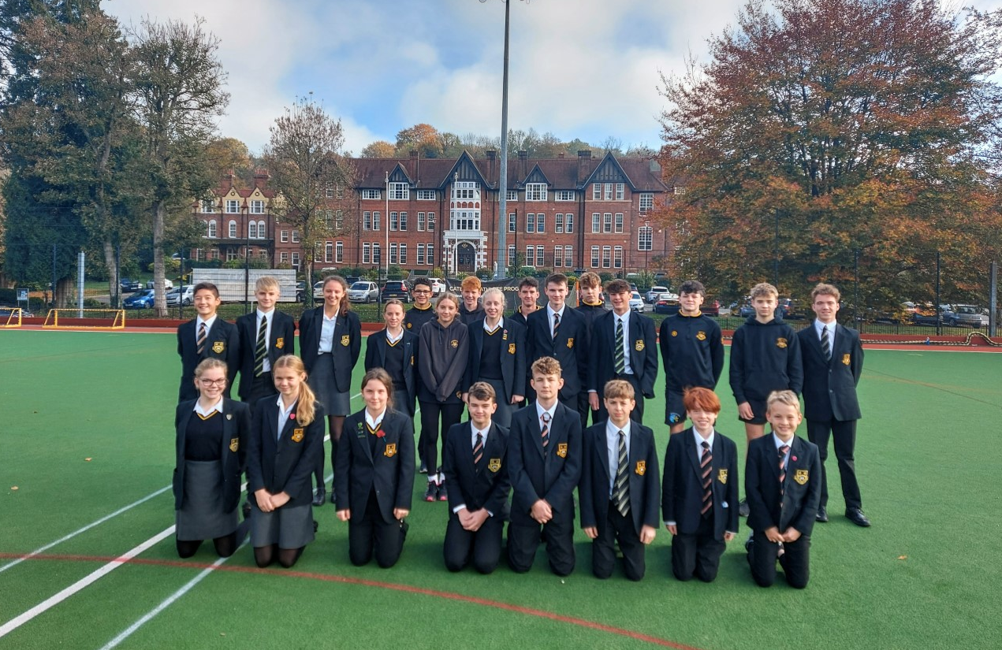

Hockey at Caterham School continues to go from strength to strength as this year has seen our largest ever number of county and regional selections. This has been just reward for the countless hours of hard work our amazing athletes have committed to over the past few years. The thriving Caterham School Hockey Academy has provided additional support and training to most of these players on top of the school indoor and outdoor hockey programme.

Director of Hockey, Peter Friend said "We are always extremely proud of our players here. This is a fantastic achievement for these young athletes and hopefully is only the first step in their representative hockey career."

Congratulations go to:
2nd Year - Lilian DB, Elise T, Ava P, Arthur P, Yannick P, Zac L, Hector H, Rory W
3rd Year - William C, Izzy C, Ava W, Ethan W, Seb TS,
4th Year - Ethan VH, Alex S, Casey M, Karlijn R, Izzy H, Josh F, William L, William T
5th Year - Louis P, Jack F
L6th - Jemima C

