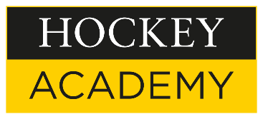
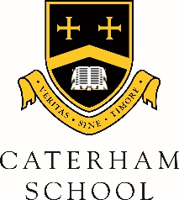

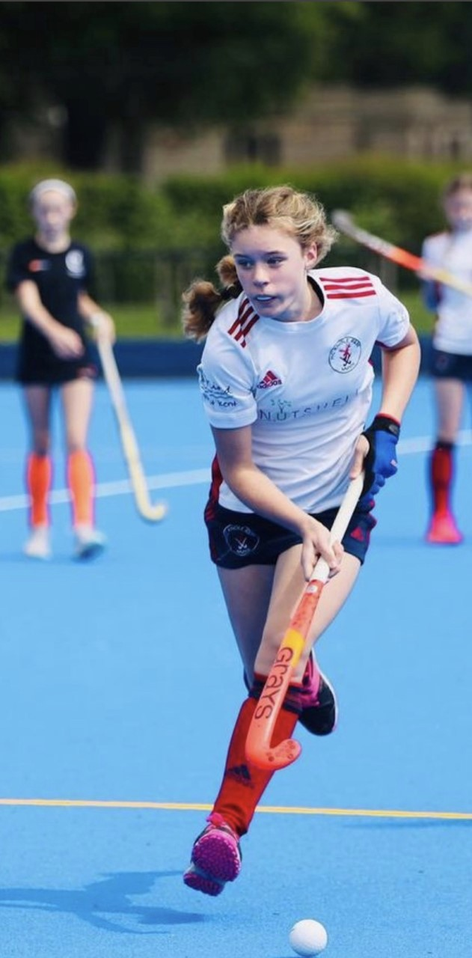
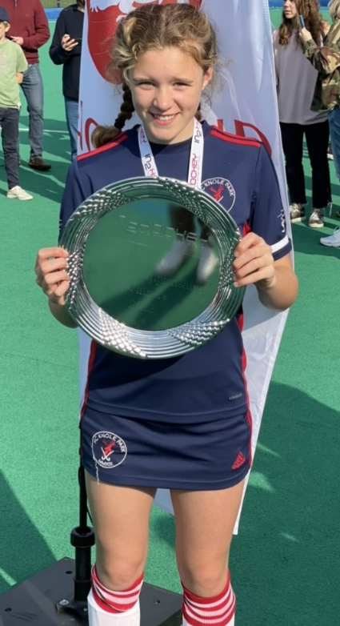

U12 National Title for Georgie O.

Last weekend, first year hockey superstar Georgie O. took home the England Hockey U12 In2Hockey Club National Title after victory with her club, Knole Park HC, at the Nottingham Hockey Centre. Some of the top club teams in the country attended the finals and Knole Park HC came through to win 3-0 vs Surbiton HC in the final.
This is a fantastic achievement for Georgie and one that shows the hard work and determination she has put in to her school and club hockey over the year. We are incredibly proud of her and look forward to seeing her continue to develop.

