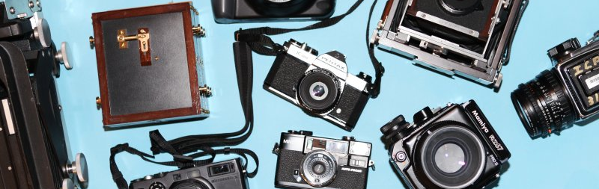
Photography Summer Task

Hello potential Lower Sixth Photographers,

Congratulations, you have chosen the best A Level course to study!
In preparation for Lower Sixth I would like you to put together a PowerPoint presentation, displaying 1-4 of your own images for each of the following themes. These should be new images, rather than ones you have taken previously.
The themes are:
- Light and Dark
- Storytelling
- Pattern and Texture
- Self
- Viewpoints

Please display these 5-20 images in a suitable way on PowerPoint, as to show off the images clearly. You will also need to include a sentence or more about each image (what it is of, how you took it, why you took it, how it links to the theme). Be prepared to show and discuss these with the group on the first day back.
You can take the images on any device, camera or phone but ensure you have thought carefully about the content, concept and composition of your images. You can edit these if you wish. Your images should show your interests and style in photography so we can get to know you and who you are/want to be as a photographer.
Please also fill in the questionnaire sheet attached.

Looking forward to seeing you all in September!
Miss Troughton
Photography A Level Questionnaire

My name is: __________________________________________________

I want to study Photography for A Level because: ________________________________________________________________________________________________________________________________________________________________________________________________

I studied an Art and Design subject at GCSE: (if so circle which one/s)
GCSE Art GCSE Fashion Textiles GCSE 3D Design/Product Design Other

My main interest in photography is: ________________________________________________________________________________________________________________________________________________________________________________________________

How much knowledge do you feel you already have of Photography?:
None at All Very Little Some A Fair Amount Lots!

Do you have any prior experience with Adobe Lightroom or Photoshop?
Yes / No

Have you previously attended Caterham School Photography Club or a Photography Club outside of school?
Yes – Caterham School Photography Club Yes – Another Photography Club No

