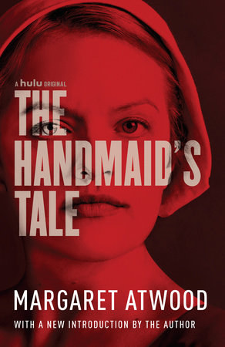
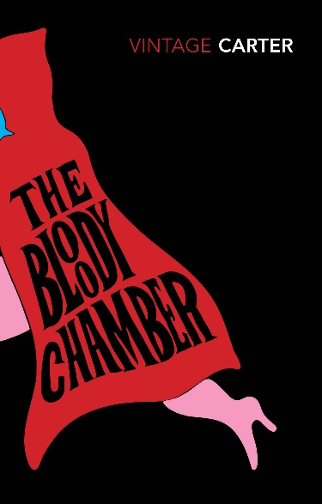
English A Level

All pupils are expected to read ‘The Bloody Chamber’ by Angela Carter (Gothic) and ‘The Handmaid’s Tale’ by Margaret Atwood (Dystopia) – you will study one of these texts as part of Comparative and Contextual paper which you start in September and your teachers will expect you to know these novels from the start of the course. Which text you study will depend on which teacher you have, but both are excellent reads that you will enjoy. The copies opposite are the ones used by your teachers and so we recommend you obtain the same version.
It is also recommended that you read ‘Dracula’ by Bram Stoker (Gothic) and ‘Nineteen Eighty-Four’ (Dystopia) as these will be the comparison texts which you will study later in the term and will have to read from September so getting ahead is advisable; again they are fantastic novels and certainly ones we feel every student of English should have read anyway.
Once you have read these, you can further develop your understanding and interests using the following lists.

Gothic Reading List
Vathek – William Beckford
The Italian – Ann Radcliffe
Light in August – William Faulkner
Outer Dark – Cormac McCarthy
The Wasp Factory – Iain Banks
Beloved – Toni Morrison
The Turn of the Screw – Henry James
The Castle of Otranto – Horace Walpole
The Hound of the Baskervilles – Sir Arthur Conan Doyle
The Mysteries of Udolpho – Ann Radcliffe
The Italian – Ann Radcliffe
Frankenstein – Mary Shelley
Northanger Abbey – Jane Austen
Wuthering Heights – Emily Bronte
The Strange Case of Dr Jekyll and Mr Hyde – Robert Louis Stevenson
The Raven – Edgar Allan Poe
The House of Seven Gables – Nathaniel Hawthorne
The Woman in White – Wilkie Collins
The Picture of Dorian Gray – Oscar Wilde
The Gormenghast Trilogy – Mervyn Peake
The Yellow Wallpaper – Charlotte Perkins Gillman
Jamaica Inn – Daphne du Maurier
Rebecca – Daphne du Maurier Poetry
The Rime of the Ancient Mariner – Samuel Taylor Coleridge
Christabel – Samuel Taylor Coleridge
Goblin Market – Christina Rosetti

Films and TV (other than adaptations of the list above)
Nosferatu: A Symphony of Horror (1922)
House of Usher (1960)
The Pit and the Pendulum (1961)
The Masque of the Red Death (1964)
Rosemary’s Baby (1968)
Near Dark (1987)
Interview with a Vampire (1994)
Sleepy Hollow (1999)
The Orphanage (2007)
The Others (2001)
Crimson Peak (2015)
True Blood (2008 – 2014)

Dystopia Reading List
Never Let Me Go – Kazua Ishiguru
The Time Machine – H.G. Wells
Brave New World – Aldous Huxley
Fahrenheit 451 – Ray Bradbury
A Clockwork Orange – Anthony Burgess
The Drowned World – J. G. Ballard
Memoirs of a Survivor – Doris Lessing
The Children of Men – P.D. James
The Road – Cormac McCarthy
The Hunger Games – Suzanne Collins
Divergent – Veronica Roth
The Power – Naomi Anderson
The Giver – Lois Lowry
Animal Farm – George Orwell
Oryx & Crake – Margaret Atwood
The Windup Girl – Paolo Bacigalupi
Logan’s Run – William F. Nolan & George Clayton Johnson
Article 5 – Kristen Simmons
Titus Alone – Mervyn Peake (final text in a trilogy)
Surface Detail – Iain M. Banks
The Caves of Steel – Isaac Asimov

Films and TV (other than adaptations of the list above)
Blade Runner (1982)
V for Vendetta (2005)
Equilibrium (2002)
Zootopia (2016)
Battle Royale (2000)
Elysium (2013)
I, Robot (2004)
Black Mirror (any episode)

