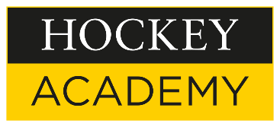

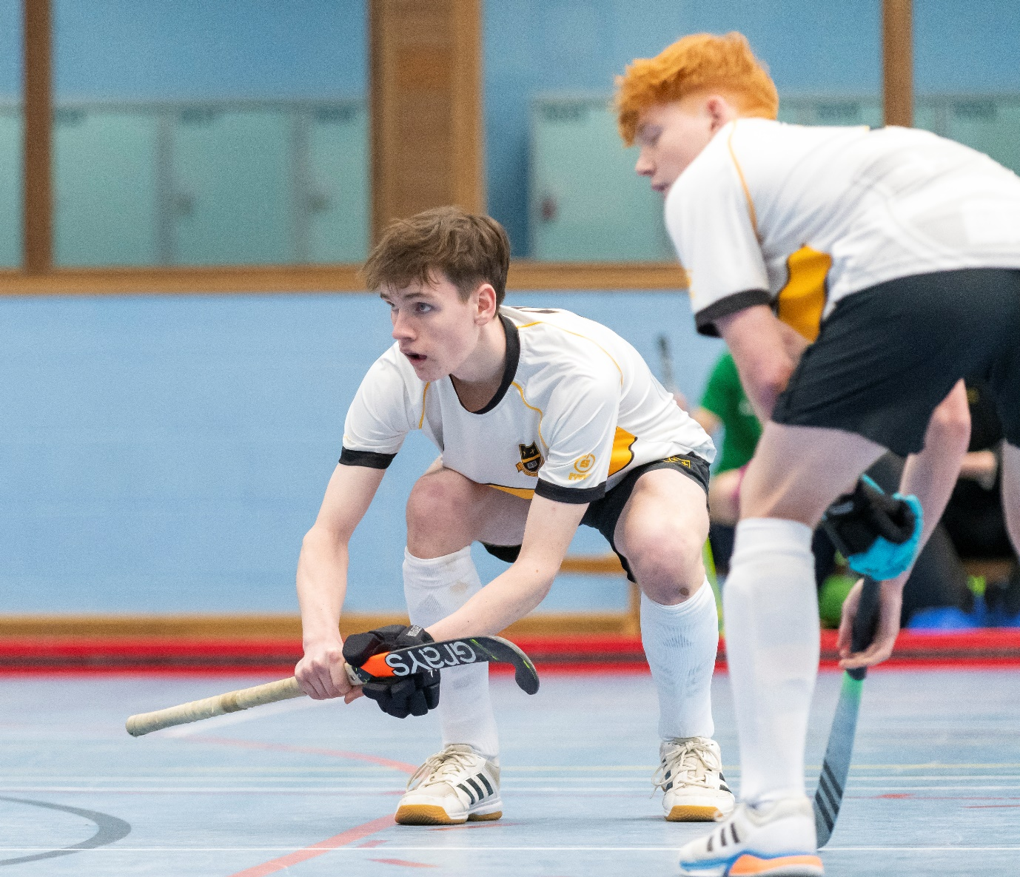

1st VI Boys Indoor Hockey Team Qualify for South East Finals
Earlier this week our 1st VI Boyd indoor hockey team took part in the U18 Surrey Indoor Hockey Finals. Qualifying out of the Surrey finals is always a tough assignment, but the boys put in terrific performances to register wins over Reigate Grammar and Cranleigh, losing narrowly to St George’s but earning a vital draw against Reeds which led to a second place finish and qualification to the SE finals. There, we will aim to win the tournament in order to qualify for this group’s second National Indoor Finals in two years (following their great run to the final last year as U16s). Best of luck to the boys in the SE finals which takes place on Monday 13 Nov.
Team: Alex S., Sammy H., Theo B., Robert T., Casey M., Ethan vH., Josh F., Will L., Ethan W.

