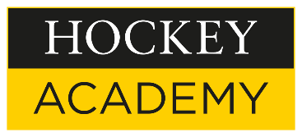
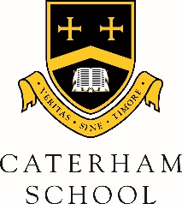

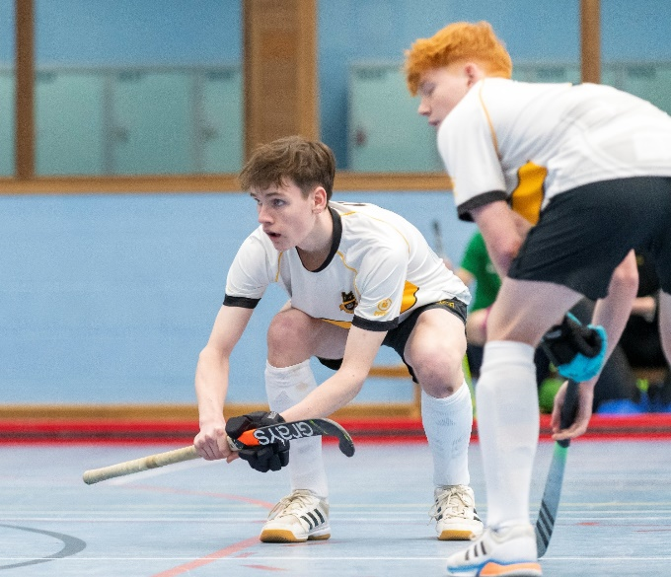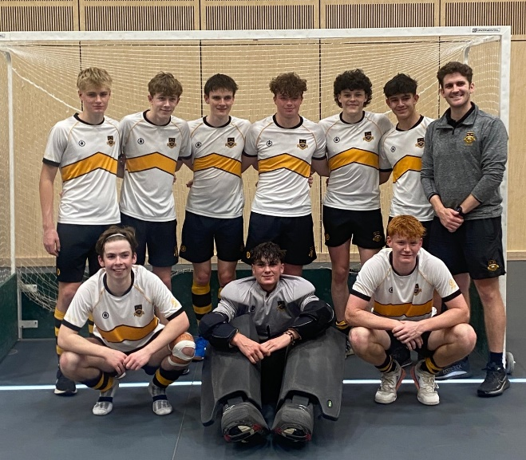

1st VI Boys Indoor Hockey Team Crowned South East Champions and Qualify for National Finals
Earlier this week, our 1st VI Boys indoor hockey team took part in the U18 Indoor Hockey South East Finals. Having qualified through the Surrey finals the week before, the boys were confident that they could put in a good performance, and the draw meant that they played Ardingly College in the first group game. A solid performance saw them come through as 2-0 winners. Next up was a convincing 3-1 win vs Simon Langton. A tense semi-final saw the boys battle to the end to take a 1-0 win vs Kent College. The final was a repeat of the first group game, as Ardingly came roaring back in their semi to beat a strong St Georges side so it would be a test to see if the boys could recreate their earlier form. Another hugely impressive and professional performance allowed the boys to take the lead early and some grit and bravery saw us stave off two penalty corners in the final minute to take the 3-2 win, the South East Championship and qualification to a second Indoor National Final in two years. The Indoor National Finals will take place at Whitgift School on Thursday 7 December.
Team: Alex S., Sammy H., Theo B., Robert T., Casey M., Ethan vH., Josh F., Will L., Ethan W.

