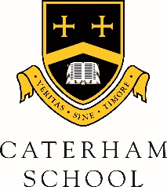

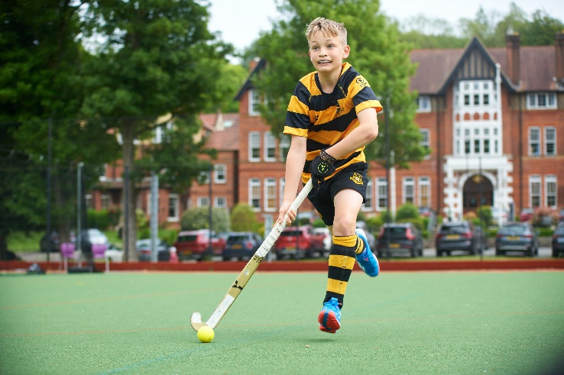

England U16 Hockey Selection for Rory

4th year student and U15A team hockey player, Rory W., has been selected into the England U16 hockey squad for the coming season. Rory has been attending a rigorous trial process since the summer and has now been selected as part of the 29 player squad which will train throughout the year in preparation for international fixtures against Germany, Belgium, Ireland, Spain, Scotland and Netherlands. This is a tremendous achievement, which is even more impressive considering he is a year young for the U16 age group.

Rory’s selection is the culmination of a long journey from being on the side of the pitch watching his brother, Zach (a current GB international hockey player and Olympian) playing for England, through to being selected for Surrey, Regional Talent Academy, UK Lions and now England U16. Rory is incredibly dedicated and driven, and we are so proud to see all that hard work pay off. Congratulations Rory!

