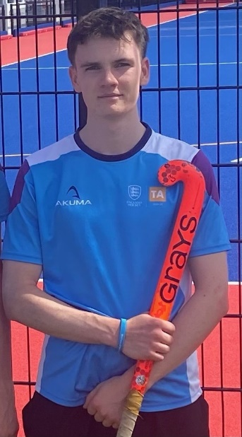
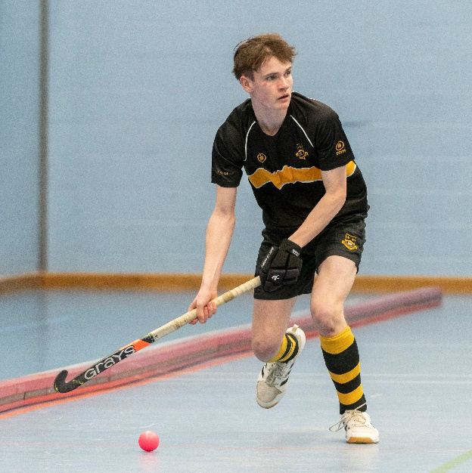

England U18 Hockey Trial for Casey

L6th Student Casey M. has been invited to trial with the England U18 Hockey Squad. This is a result of him putting in some great performances for his Sevenoaks Talent Academy over the past two years, where he has been competing against the best young players from across the country. Casey will attend a trial just before Christmas with the hope that it will lead to a full England U18 call up.

Casey is an incredibly dedicated and committed hockey player, playing his club hockey for Oxted HC as well as being part of the School’s U18 indoor hockey team that have recently qualified for their second National Finals in two years. Congratulations Casey, and best of luck!

