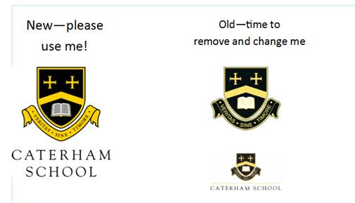

**A LEVEL CHINESE & RUSSIAN OPTIONS**

**FOR SUMMER 2026**

Name: ___________________________________________________

* I wish to register for A Level Russian
* I wish to register for A Level Cantonese
* I wish to register for A Level Mandarin

**Please return this form to Mr Garcia (**[Carlos.garcia@caterhamschool.co.uk](mailto:Carlos.garcia@caterhamschool.co.uk)**) by**

**Monday 16 June 2025**